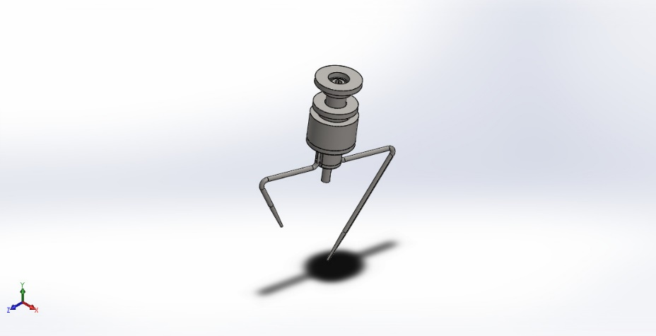
  Simulation of Assem4
  Date: Thursday, April 9, 2026
  Designer: Solidworks
  Study name: assemply_1_static
  Analysis type: Static
  Table of Contents
  Description 1
  Assumptions 2
  Model Information 3
  Study Properties 6
  Units 6
  Material Properties 7
  Loads and Fixtures 8
  Connector Definitions 8
  Interaction Information 9
  Mesh information 9
  Sensor Details 9
  Resultant Forces 10
  Beams 10
  Study Results 11
  Conclusion 13

Description
No Data

Assumptions

Model Information

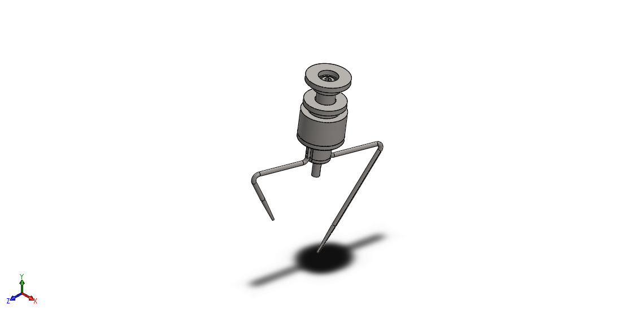
Model name: Assem4
Current Configuration: Default
Solid Bodies
Document Name and Reference | Treated As | Volumetric Properties | Document Path/Date Modified
B6702ZZ.sldprt  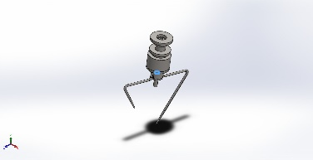 | Solid Body | Mass:0.00515218 kg  Volume:6.44023e-07 m^3  Density:8,000 kg/m^3  Weight:0.0504914 N | C:\Users\ENG-HASSAN\OneDrive\Documents\Solidworks\assemply\B6702ZZ.sldprt  Mar 29 01:12:41 2026
B6804ZZ.sldprt  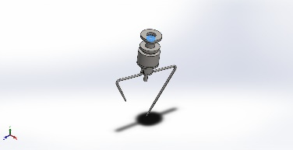 | Solid Body | Mass:0.0270741 kg  Volume:3.38426e-06 m^3  Density:8,000 kg/m^3  Weight:0.265326 N | C:\Users\ENG-HASSAN\OneDrive\Documents\Solidworks\assemply\B6804ZZ.sldprt  Mar 29 01:12:41 2026
B6809ZZ.sldprt  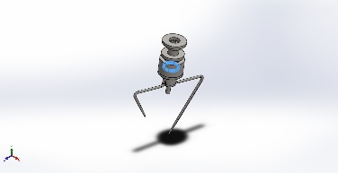 | Solid Body | Mass:0.0557469 kg  Volume:6.96836e-06 m^3  Density:8,000 kg/m^3  Weight:0.546319 N | C:\Users\ENG-HASSAN\OneDrive\Documents\Solidworks\assemply\B6809ZZ.sldprt  Mar 29 01:12:41 2026
B6809ZZ.sldprt  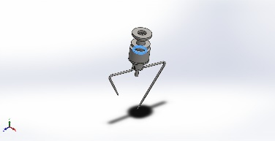 | Solid Body | Mass:0.0557469 kg  Volume:6.96836e-06 m^3  Density:8,000 kg/m^3  Weight:0.546319 N | C:\Users\ENG-HASSAN\OneDrive\Documents\Solidworks\assemply\B6809ZZ.sldprt  Mar 29 01:12:41 2026
B6902ZZ.sldprt  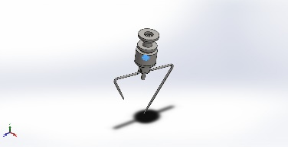 | Solid Body | Mass:0.0224059 kg  Volume:2.80074e-06 m^3  Density:8,000 kg/m^3  Weight:0.219578 N | C:\Users\ENG-HASSAN\OneDrive\Documents\Solidworks\assemply\B6902ZZ.sldprt  Mar 29 01:12:41 2026
MUEN15.sldprt  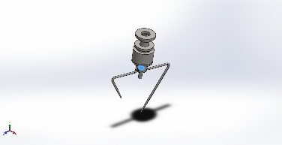 | Solid Body | Mass:0.011334 kg  Volume:1.41675e-06 m^3  Density:8,000 kg/m^3  Weight:0.111073 N | C:\Users\ENG-HASSAN\OneDrive\Documents\Solidworks\assemply\MUEN15.sldprt  Mar 29 01:12:45 2026
MUEN45.sldprt  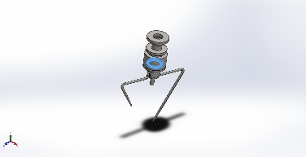 | Solid Body | Mass:0.0670728 kg  Volume:8.38411e-06 m^3  Density:8,000 kg/m^3  Weight:0.657314 N | C:\Users\ENG-HASSAN\OneDrive\Documents\Solidworks\assemply\MUEN45.sldprt  Mar 29 01:12:45 2026
Split Line1  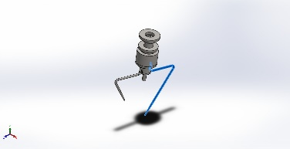 | Solid Body | Mass:0.137864 kg  Volume:1.7233e-05 m^3  Density:8,000 kg/m^3  Weight:1.35107 N | C:\Users\ENG-HASSAN\OneDrive\Documents\Solidworks\assemply\blenderaugerlong.SLDPRT  Mar 29 01:12:42 2026
M6 Tapped Hole1  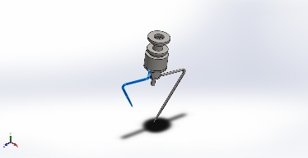 | Solid Body | Mass:0.0931969 kg  Volume:1.16496e-05 m^3  Density:8,000 kg/m^3  Weight:0.91333 N | C:\Users\ENG-HASSAN\OneDrive\Documents\Solidworks\assemply\blenderaugershortonly.SLDPRT  Mar 29 01:12:42 2026
M6 Tapped Hole1  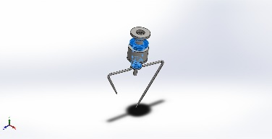 | Solid Body | Mass:0.86854 kg  Volume:0.000108567 m^3  Density:8,000 kg/m^3  Weight:8.51169 N | C:\Users\ENG-HASSAN\OneDrive\Documents\Solidworks\assemply\blenderseat.SLDPRT  Mar 29 01:12:42 2026
Chamfer2  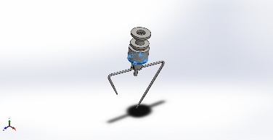 | Solid Body | Mass:0.293127 kg  Volume:3.66409e-05 m^3  Density:8,000 kg/m^3  Weight:2.87265 N | C:\Users\ENG-HASSAN\OneDrive\Documents\Solidworks\assemply\blocker.SLDPRT  Mar 29 01:12:42 2026
Extrude2  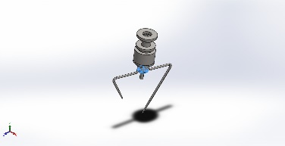 | Solid Body | Mass:0.0720602 kg  Volume:9.00752e-06 m^3  Density:8,000 kg/m^3  Weight:0.70619 N | C:\Users\ENG-HASSAN\OneDrive\Documents\Solidworks\assemply\blocker2.SLDPRT  Mar 29 01:12:42 2026
M4 Tapped Hole1  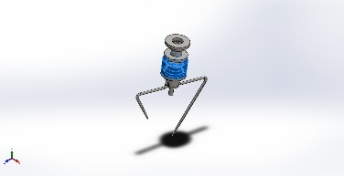 | Solid Body | Mass:1.21131 kg  Volume:0.000151413 m^3  Density:8,000 kg/m^3  Weight:11.8708 N | C:\Users\ENG-HASSAN\OneDrive\Documents\Solidworks\assemply\outbearingseat.SLDPRT  Mar 29 01:12:45 2026
Extrude6  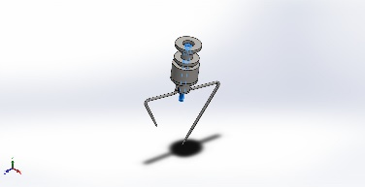 | Solid Body | Mass:0.320953 kg  Volume:4.01191e-05 m^3  Density:8,000 kg/m^3  Weight:3.14534 N | C:\Users\ENG-HASSAN\OneDrive\Documents\Solidworks\assemply\shaft.SLDPRT  Mar 29 01:12:45 2026
Extrude3  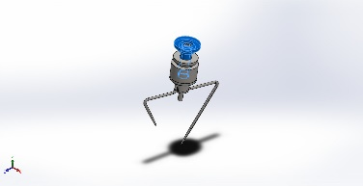 | Solid Body | Mass:0.836782 kg  Volume:0.000104598 m^3  Density:8,000 kg/m^3  Weight:8.20046 N | C:\Users\ENG-HASSAN\OneDrive\Documents\Solidworks\assemply\sleeve7.SLDPRT  Mar 29 01:12:45 2026

Study Properties
Study name | assemply_1_static
Analysis type | Static
Mesh type | Solid Mesh
Thermal Effect: | On
Thermal option | Include temperature loads
Zero strain temperature | 298 Kelvin
Include fluid pressure effects from SOLIDWORKS Flow Simulation | Off
Solver type | Automatic
Inplane Effect: | Off
Soft Spring: | Off
Inertial Relief: | Off
Incompatible bonding options | Automatic
Large displacement | On
Compute free body forces | On
Friction | Off
Use Adaptive Method: | Off
Result folder | SOLIDWORKS document (G:\assemply\assemply)

Units
Unit system: | SI (MKS)
Length/Displacement | mm
Temperature | Kelvin
Angular velocity | Rad/sec
Pressure/Stress | N/m^2

Material Properties
Model Reference | Properties | Components
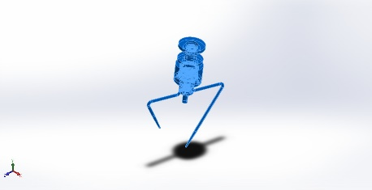 |  | SolidBody 1(B6702ZZ.sldprt)(B6702ZZ-1),  SolidBody 1(B6804ZZ.sldprt)(B6804ZZ-1),  SolidBody 1(B6809ZZ.sldprt)(B6809ZZ-1),  SolidBody 1(B6809ZZ.sldprt)(B6809ZZ-2),  SolidBody 1(B6902ZZ.sldprt)(B6902ZZ-1),  SolidBody 1(MUEN15.sldprt)(MUEN15-1),  SolidBody 1(MUEN45.sldprt)(MUEN45-1),  SolidBody 1(Split Line1)(blenderaugerlong-1),  SolidBody 1(M6 Tapped Hole1)(blenderaugershortonly-1),  SolidBody 1(M6 Tapped Hole1)(blenderseat-1),  SolidBody 1(Chamfer2)(blocker-1),  SolidBody 1(Extrude2)(blocker2-1),  SolidBody 1(M4 Tapped Hole1)(outbearingseat-1),  SolidBody 1(Extrude6)(shaft-1),  SolidBody 1(Extrude3)(sleeve7-1)
  Name: | AISI 304
  Model type: | Linear Elastic Isotropic
  Default failure criterion: | Max von Mises Stress
  Yield strength: | 2.06807e+08 N/m^2
  Tensile strength: | 5.17017e+08 N/m^2
  Elastic modulus: | 1.9e+11 N/m^2
  Poisson's ratio: | 0.29
  Mass density: | 8,000 kg/m^3
  Shear modulus: | 7.5e+10 N/m^2
  Thermal expansion coefficient: | 1.8e-05 /Kelvin
Curve Data:N/A

Loads and Fixtures
Fixture name | Fixture Image | Fixture Details
Fixed-1 | 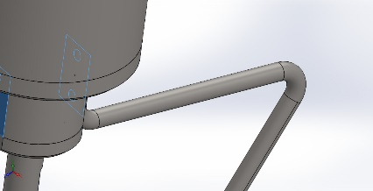
  Entities: | 2 face(s)
  Type: | Fixed Geometry
Resultant Forces
Components | X | Y | Z | Resultant
Reaction force(N) | 53.3007 | 44.7518 | 54.4406 | 88.3599
Reaction Moment(N.m) | 0 | 0 | 0 | 0

Load name | Load Image | Load Details
Pressure-1 | 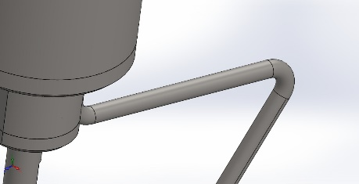
  Entities: | 1 face(s)
  Type: | Normal to selected face
  Value: | 10,000
  Units: | N/m^2
  Phase Angle: | 0
  Units: | deg
Torque-1 | 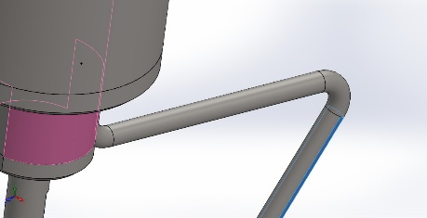
  Entities: | 2 face(s)
  Reference: | Face< 1 >
  Type: | Apply torque
  Value: | 2.2 N.m

Connector Definitions
No Data

Interaction Information

Interaction | Interaction Image | Interaction Properties
Global Interaction | 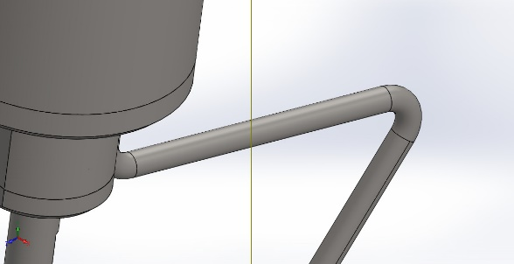
  Type: | Bonded
  Components: | 1 component(s)
  Options: | Independent mesh

Mesh information
Mesh type | Solid Mesh
Mesher Used: | Blended curvature-based mesh
Jacobian points for High quality mesh | 16 Points
Maximum element size | 0.383237 in
Minimum element size | 0.0191618 in
Mesh Quality | High
Remesh failed parts independently | Off
Reuse mesh for identical parts in an assembly (Blended curvature-based mesher only) | Off

Mesh information - Details
Total Nodes | 486188
Total Elements | 295910
Maximum Aspect Ratio | 21.753
% of elements with Aspect Ratio < 3 | 97.2
Percentage of elements with Aspect Ratio > 10 | 0.11
Percentage of distorted elements | 0
Time to complete mesh(hh;mm;ss): | 00:00:56
Computer name: | HASSAN

Sensor Details
No Data

Resultant Forces

Reaction forces
Selection set | Units | Sum X | Sum Y | Sum Z | Resultant
Entire Model | N | 91.5508 | 46.3413 | 98.5253 | 142.254

Reaction Moments
Selection set | Units | Sum X | Sum Y | Sum Z | Resultant
Entire Model | N.m | 0 | 0 | 0 | 0

Free body forces
Selection set | Units | Sum X | Sum Y | Sum Z | Resultant
Entire Model | N | 0 | 0 | 0 | 0

Free body moments
Selection set | Units | Sum X | Sum Y | Sum Z | Resultant
Entire Model | N.m | 0 | 0 | 0 | 0

Beams
No Data

Study Results

Name | Type | Min | Max
Stress1 | VON: von Mises Stress | 0.000e+00N/m^2  Node: 70847 | 7.476e+07N/m^2  Node: 437692
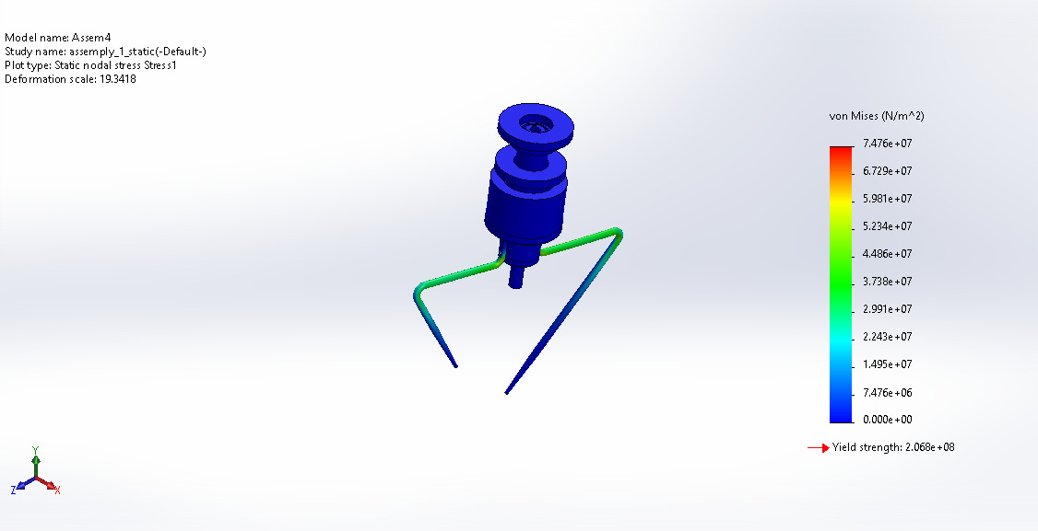
Assem4-assemply_1_static-Stress-Stress1

Name | Type | Min | Max
Displacement1 | URES: Resultant Displacement | 0.000e+00mm  Node: 70847 | 2.241e+00mm  Node: 426121
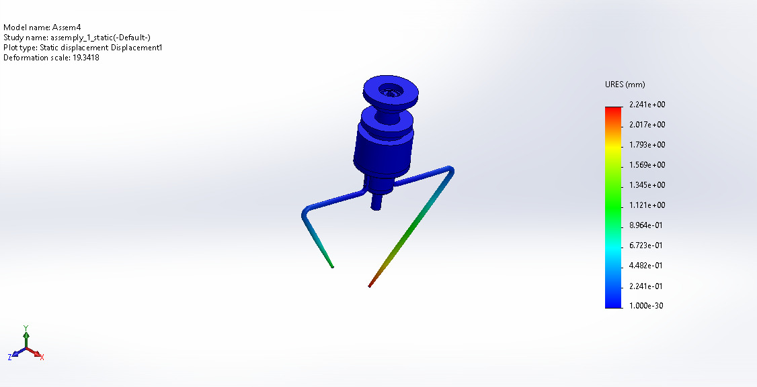
Assem4-assemply_1_static-Displacement-Displacement1

Name | Type | Min | Max
Strain1 | ESTRN: Equivalent Strain | 0.000e+00  Element: 42691 | 2.230e-04  Element: 267660
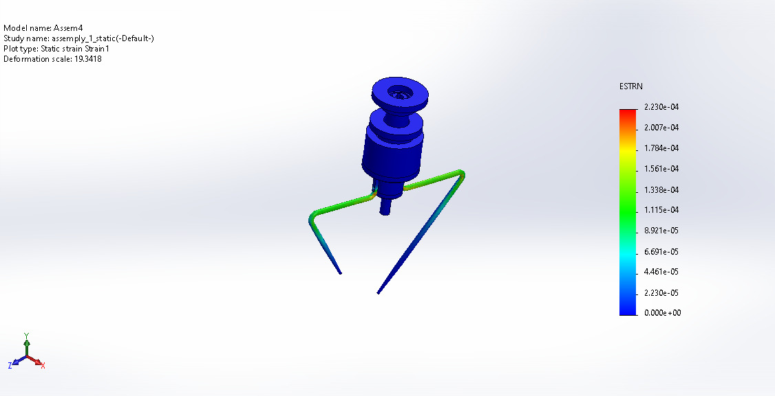
Assem4-assemply_1_static-Strain-Strain1

Name | Type | Min | Max
Factor of Safety1 | Max von Mises Stress | 2.766e+00  Node: 437692 | 1.000e+16  Node: 70847
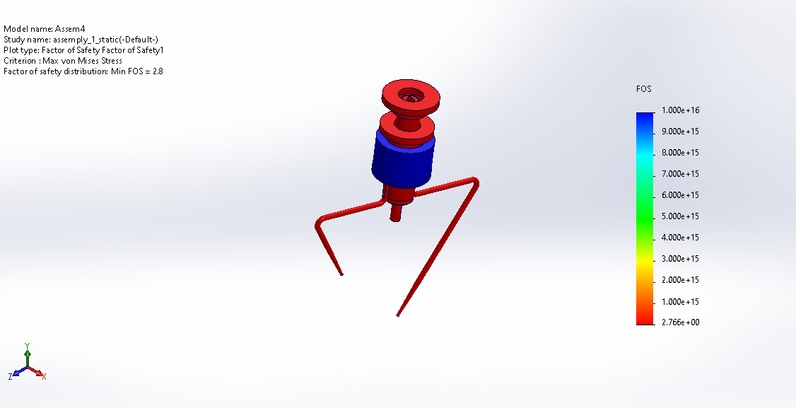
Assem4-assemply_1_static-Factor of Safety-Factor of Safety1

Name | Type | Min | Max
Factor of Safety2 | Max von Mises Stress | 2.766e+00  Node: 437692 | 1.000e+16  Node: 70847
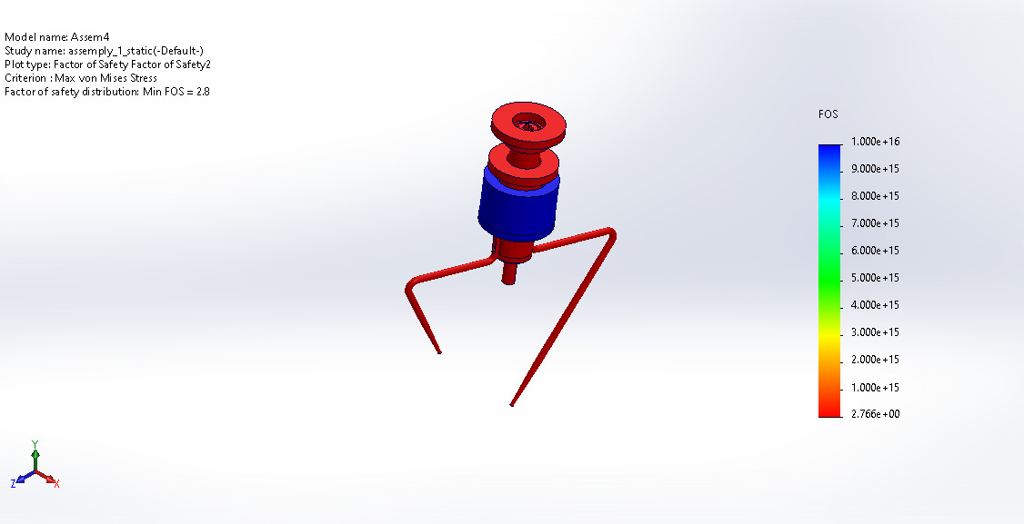
Assem4-assemply_1_static-Factor of Safety-Factor of Safety2

Conclusion

